CHAPTER 10
DYNAMICS OF ROTATIONAL MOTION
Discussion Questions
Q10.1 Yes. For example, a force applied tangentially to the rim of a disk initially at rest on a horizontal frictionless surface produces both a net force that accelerates the center of mass of the object and also a torque that starts the disk rotating about the center of mass.

Q10.2 It is better to use small, light wheels. Some of the initial gravitational potential energy of the racer is converted into rotational kinetic energy 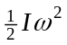 of the wheels. You want this to be as small as possible, so that most of the potential energy goes into translational kinetic energy of the center of mass of the racer. For the same reason, it is better to use solid wheels, that have a smaller for the same total mass of the wheel.

Q10.3 Reducing the weight of the wheels reduces the moment of inertia of the wheels and less torque is required to give them a given angular acceleration. Reducing the total mass of the bike also reduces the net horizontal force required for a given linear acceleration but for this motion it doesn’t matter where on the bike the weight is removed.

Q10.4 The friction force that opposes the motion of the car while stopping produces a torque about the center of gravity of the car that tends to rotate the car such that the rear is raised and the front is lowered. See Fig. DQ10.4a. When accelerating, the friction force is in the direction the car is moving and produces a torque about the center of gravity that tends to rotate the car in the opposite direction, so the front end is raised. See Fig. DQ10.4b. For a large acceleration the normal force at the front wheels is reduced, so traction is lost there.

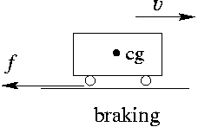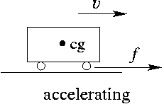

Figure DQ10.4a Figure DQ10.4b

Q10.5 Holding her arms out increases her moment of inertia for an axis through her center of mass. By Eq.(10.7), this means a given gravity torque that arises when she leans slightly to one side or the other produces a smaller angular acceleration.

Q10.6 The grinding wheel increases the moment of inertia of the shaft. The torque applied by the motor then produces a smaller angular acceleration.

Q10.7 For work, the distance used is the component of displacement along the direction of the force. For torque, the distance used is the component perpendicular to the force of the distance from the axis to the point of application of the force. Work and torque have the same units but are different quantities.

Q10.8 Roll it down the incline, alongside a solid ball and then alongside a hollow ball. A solid ball will reach the bottom of the incline before a hollow ball.

Q10.9 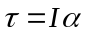. 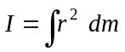. 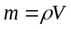 so 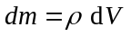and 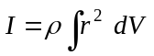. If each dimension is doubled, then I is increased by a factor of 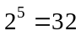. The angular acceleration of the larger object will be 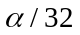. For a specific example of a disk with radius R, thickness t and axis as in Fig. 9.4f, 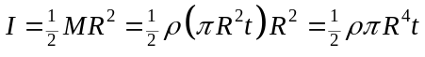. Doubling R and t increases I by a factor of 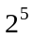.

Q10.10 For the hanging mass, 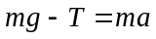. For the pulley, 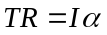. 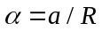 so 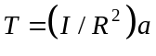. 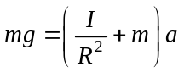 and 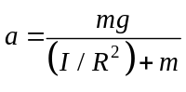. 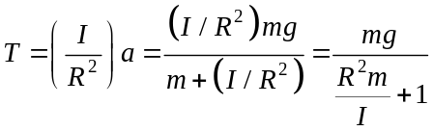. The pulley in the shape of hoop has larger I and therefore the tension T in the string is greater in that case. One way to see this qualitatively is to note that the greater rotational inertia of the loop causes the mass to fall with less downward acceleration when this pulley is used. The smaller a is for the hanging mass, the closer the tension is to the weight of the hanging mass. Note that to have the same mass and radius, the hoop must be made of material of greater density than the solid pulley.

Q10.11 The gravity torque acts at the center of gravity of the baton and therefore produces no angular acceleration about this point.

Q10.12 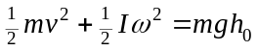, where v and are the linear and angular speeds of the ball at the bottom of the hill. 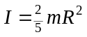 and 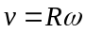, so 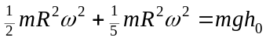. 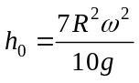. (a) The height reached by the ball for a given angular speed at the bottom is proportional to 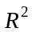. So, the height reached will be 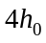 if R is doubled. (b) The mass divides out of the conservation of energy expression so the maximum height will still be 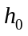. (c) Same as in part (a), . (d) The height reached is proportional to 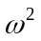, so the maximum height will be .

Q10.13 Refer to Fig.10.13. All points have 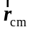 to the right. The resultant velocity of each point is thus to the right plus the velocity for rotation around the center of mass. All points have a velocity component to the right so there is no point where the velocity is purely vertical. The rotation gives a maximum component 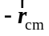, that is to the left. The point of contact with the surface has a resultant velocity of zero, but no point has a horizontal component opposite to the velocity of the center of mass. If the wheel is slipping, the speed at the rim due to rotation is greater than 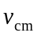. It is still correct that no point has a purely vertical velocity, but now the top of the wheel can have a horizontal velocity opposite to the velocity of the center of mass.

Q10.14 Let the moment of inertia of each object be 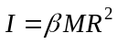, where 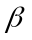 is a different constant for each object. The object with the smallest reaches the bottom first. For a hoop, 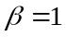; for a uniform solid cylinder, 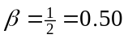; for a spherical shell, 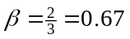, and for a uniform solid sphere, 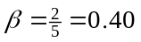. So, the order of arrival, first to last, is: solid sphere, solid cylinder, spherical shell, and hoop. The mass and radii divide out in the calculation of the speed at the bottom of the incline, so it doesn’t matter if the mass and radii are the same. All that matters is the shape, the way in which the mass is distributed relative to the axis.

Q10.15 The ball will go higher up the hill if the hill has enough friction to prevent slipping.
energy conservation: As the ball rolls on the horizontal surface at the bottom of the hill it has both translational and rotational kinetic energy. If the hill is perfectly smooth the ball continues to rotate with the same angular speed and only the initial translational kinetic energy is converted into gravitational potential energy; at the maximum height up the hill the ball is still spinning at the same rate as initially. If there is enough friction to prevent slipping then the ball has stopped rotating at the maximum height and both the initial translational and rotational kinetic energies are converted into gravitational potential energy.
Newton’s 2nd law: When there is no friction the net force on the ball as it rolls up the hill is 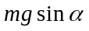 directed down the incline ( is the slope angle of the hill). With friction, there is a friction force 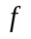 directed up the incline and the net force down the incline is 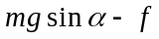. With friction the acceleration opposing the translational motion is less and the ball travels a greater distance before coming to rest.

Q10.16 Consider yourself plus the turntable as the system. There are no external torques on this system, so the total angular momentum is constant. As you move farther from the axis the moment of inertia of the system increases and in order to maintain the same angular momentum the rotation speed decreases.

Q10.17 In the oceans the water will be farther from the axis of rotation of the earth than when it is frozen as ice near the poles. The moment of inertia of the earth will increase and from conservation of angular momentum the rotation rate will decrease. The length of a day (the time for one full rotation) will increase.

Q10.18 Since angular momentum is given by 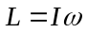and rotational kinetic energy is given by 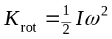, 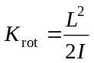. If they have the same , they will have the same 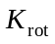 only if they have the same . And since 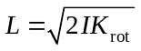, if they have the same rotational kinetic energy they will have the same angular momentum only if they have the same . And rotational kinetic energy is a scalar whereas rotational kinetic energy is a vector. Even if they have the same magnitude of angular momentum the angular momentum vectors of the two objects could be different if they are in different directions.

Q10.19 The weights have the same angular velocity, and hence the same angular momentum, just after they are released as just before they were released. The angular momentum of the student doesn’t change and her angular speed remains the same. Her angular speed would change if she threw the weights in the tangential direction, instead of just letting go of them.

Q10.20 The particle has angular momentum with constant magnitude 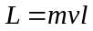.

Q10.21 The equation 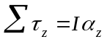 is valid only for rigid bodies, for which is constant. Eq. (10.29) is always true whereas Eq.(10.7) is true only if is constant. There is an analogous statement for the dynamics of translational motion: Eq.(8.4) is true in general; 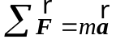 is equivalent, and correct, only when the mass of the system is constant during the motion.
Q10.22 Eq.(10.22) is derived using Eq.(10.7), which is correct only when is constant. When is not constant, Eq.(10.22) does not apply. The extra kinetic energy comes from the work done by the radial force the professor applies when he pulls in the weights.

Q10.23 Her linear momentum is not conserved, because of the net force on her due to gravity. The force acts at her center of gravity, so provides no net torque for rotation about her center of gravity.

Q10.24 When you stop the raw egg, the raw insides of the egg, which are only loosely coupled to the shell, keep spinning. This energy couples back to the motion of the light shell when the egg is released. When you stop a hard-boiled egg, the whole egg stops.
Q10.25 Without the small rotor, when the large rotor changes angular speed the helicopter body would rotate in the opposite direction to conserve angular momentum. The small rotor causes an external torque from the air that keeps the body of the helicopter from rotating. The two counter-rotating main rotors have zero total angular momentum regardless of their angular speed.

Q10.26 So long as the center of gravity is directly above the pivot there is no gravity torque to cause precession about the pivot.

Q10.27 The processional angular speed  is given by 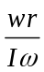. (a) If is doubled, is halved. (b) If is doubled, is doubled. (c) If is doubled, is halved. (d) If is doubled, is doubled. (e) is increased by a factor of four and 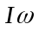is increased by a factor of four. The factors of four cancel and is unchanged.

Q10.28 According to Eq.(10.33), as the angular speed of rotationdecreases the precession angular speed increases and the precession period decreases. The gyroscope has slowed down due to friction torque at its axis.

Q10.29 This increases the gravity torque and causes the gyroscope to precess at a faster rate.

Q10.30 The spinning bullet has angular momentum that tends to stay constant as the bullet travels through the air.

